Week-14 ITC Lab

CODE:
<!DOCTYPE html>
<html lang="en">
<head>
<meta charset="UTF-8">
<meta name="viewport" content="width=device-width, initial-scale=1.0">
<title>Document</title>
</head>
<script>
// alert('JS is working');
console.log("JS is working in console log");
</script>

</script>

<body>
<h1>Umais </h1>
<h2>Bilal</h2>
<h3>Raheem</h3>
</body>
</html>

Alert – generates a pop-up.
console.log – doesn’t generate a pop-up

Since we have the script tag before our code, the popup will appear first and then the HTML structure would appear on the screen.

Once we press the button, the HTML code appears.

JavaScript Targeting
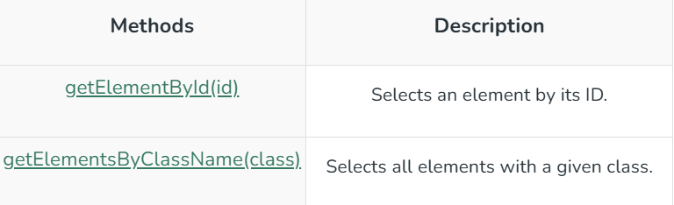

<html>
<head>

<script>
const element = document.getElementById("intro");
document.getElementById("demo").innerHTML =
"GeeksforGeeks introduction is: " + element.innerHTML;
</script>

</head>

<body>
<h2>GeeksforGeeks</h2>
<!-- Finding the HTML Elements by their Id in DOM -->
<p id="intro">
A Computer Science portal for geeks.
</p>
<p>
This example illustrates the <b>getElementById</b> method.
</p>
<p id="demo"></p>

</body>
</html>

Line 4: We are targeting the element; the whole code is the part of the DOM. Targeted element is passed into the variable “element”
Paragraph tag – info is saved in the variable
CONCATENATION:

The command:
<p id="demo"></p>

document.getElementById("demo").innerHTML =
"GeeksforGeeks introduction is: " + element.innerHTML;

After P opening tag (<p id="demo">HERE</p>)the below is being written:
Line 5: Writing "GeeksforGeeks introduction is: "
+
element.innerHTML;

element.innerHTML Targets:
<p id="intro">
A Computer Science portal for geeks.
</p>

The id “demo” doesn’t work here because JavaScript is called before the “id” tag.
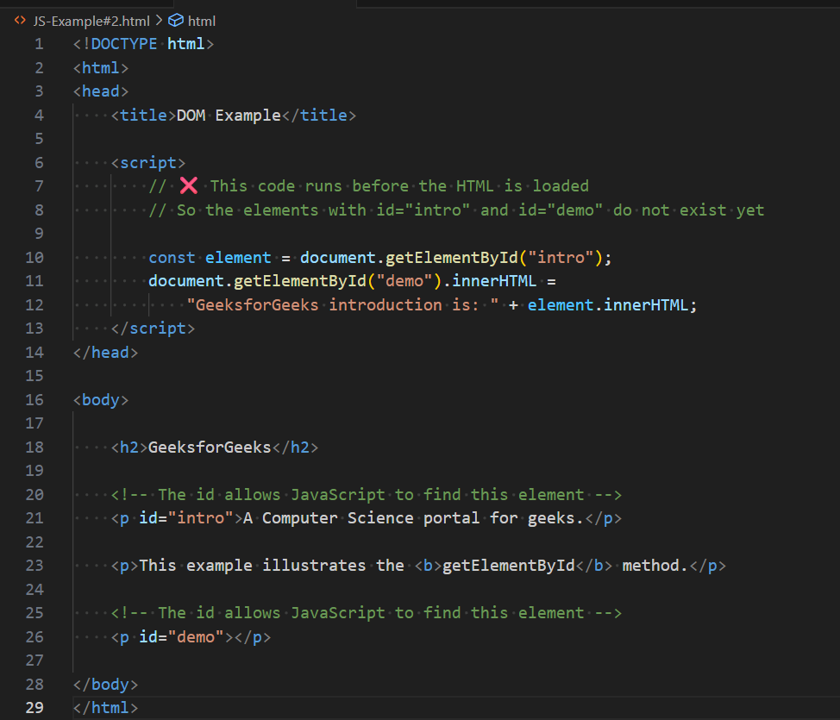
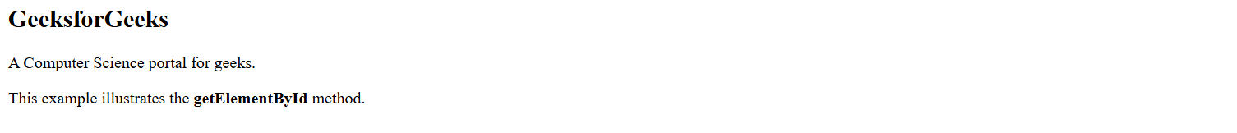

Now, the “demo” id works!
<html>

<body>
<h2>GeeksforGeeks</h2>
<!-- Finding the HTML Elements by their Id in DOM -->
<p id="intro">
A Computer Science portal for geeks.
</p>
<p>
This example illustrates the <b>getElementById</b> method.
</p>
<p id="demo"></p>

<script>
const element = document.getElementById("intro");
document.getElementById("demo").innerHTML =
"GeeksforGeeks introduction is: " + element.innerHTML;
</script>

</body>
</html>

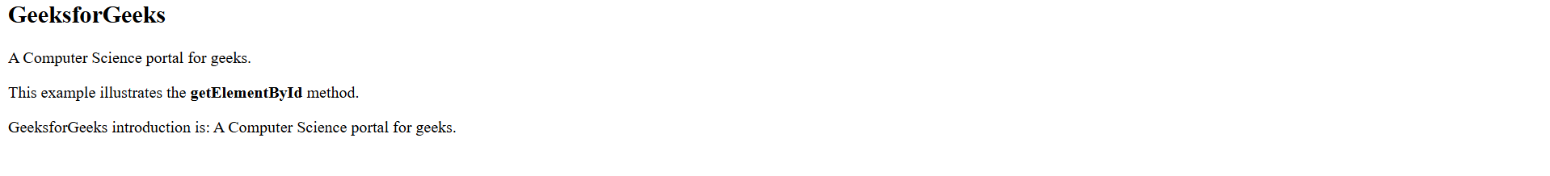

On-Click Action Trigger
<!DOCTYPE html>
<html lang="en">
<head>
<meta charset="UTF-8">
<meta name="viewport" content="width=device-width, initial-scale=1.0">
<title>Document</title>

</head>
<body>
<h1>
Hello World!
</h1>

<h3>
Welcome to JS!
</h3>

<button id="btn">Show Paragraph</button>

<script>

function greet(){
const btn = document.getElementById('btn');

btn.addEventListener('click', () =>{
alert('U clicked a button')
});
}

greet();

</script>

</body>
</html>
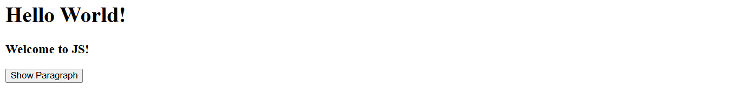
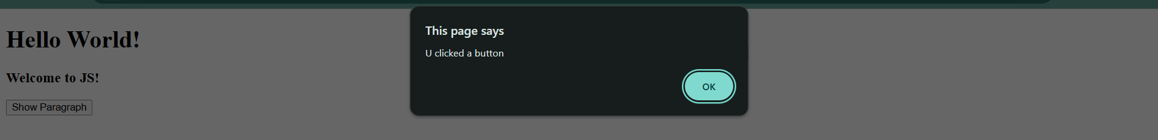

Action button triggers something (last code)
